Date:15-10-2026
CO 1 ASSESSMENT TOOL 3

CODING CHALLENGE

COURSE NAME: NATURAL LANGUAGE PROCESSING

COURSECODE: DSA0308

NAME:BODDU RAMYA REG.NO: 192424183

Section 1: Intelligent Email and Password Validator using Regular Expression
1. Problem Statement:
A software company is developing a user registration system. Before creating an account, the system must validate user credentials based on predefined security policies.
Code:
import re
def validate_email(email):
pattern = r'^[A-Za-z][A-Za-z0-9._]*@[A-Za-z]+\.(com|org|edu|net|in) $'
if re.match(pattern, email):
print("Valid Email")
else:
print("Invalid Email")
def validate_password(password):
pattern = r'^(?=.*[A-Z])(?=.*[a-z])(?=.*\d)(?=.*[@#$%&!])[A-Za-z\d@#$%&!]{8,}$'
if re.match(pattern, password):
print("Strong Password")
else:
print("Weak Password")
def validate_mobile(mobile):
pattern = r'^[6-9]\d{9}$'
if re.match(pattern, mobile):
print("Valid Mobile Number")
else:
print("Invalid Mobile Number")
email = input("Enter Email Address: ")
password = input("Enter Password: ")
mobile = input("Enter Mobile Number: ")
validate_email(email)
validate_password(password)
validate_mobile(mobile)
Expected Output:
Enter Email Address: Ramya123@gmail.com
Enter Password: 123456
Enter Mobile Number: 6305073729
Valid Email
Weak Password
Valid Mobile Number
Output:
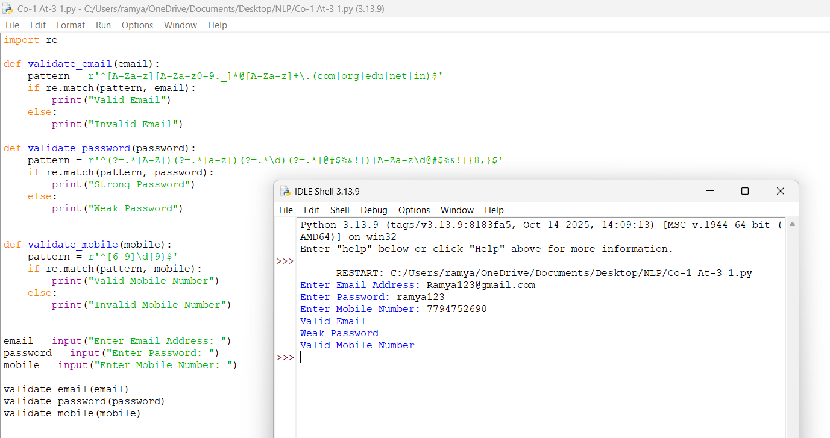

Section 2: Design a Finite State Automata (FSA) Simulator
2.Problem Statement
Develop a Python-based Deterministic Finite Automata (DFA) simulator.

Code:
states = input("Enter states (space-separated): ").split()
alphabet = input("Enter input alphabet (space-separated): ").split()
print("Enter transition table:")
transition = {}
for state in states:
transition[state] = {}
for symbol in alphabet:
next_state = input(f"Transition({state}, {symbol}): ")
transition[state][symbol] = next_state
initial_state = input("Enter initial state: ")
final_states = input("Enter final states (space-separated): ").split()
n = int(input("Enter number of input strings: "))
for i in range(n):
string = input(f"Enter string {i + 1}: ")
current_state = initial_state
path = [current_state]
valid = True
for symbol in string:
if symbol not in alphabet:
valid = False
break
current_state = transition[current_state][symbol]
path.append(current_state)
print("Transition Path:", " → ".join(path))
if valid and current_state in final_states:
print("Accepted")
else:
print("Rejected")
Expected Output:
Enter states (space-separated): q0 q1 q2
Enter input alphabet (space-separated): a b
Enter transition table:
Transition(q0, a): q1
Transition(q0, b): q0
Transition(q1, a): q1
Transition(q1, b): q2
Transition(q2, a): q1
Transition(q2, b): q0
Enter initial state: q0
Enter final states (space-separated): q2
Enter number of input strings: 2
Enter string 1: abaab
Transition Path: q0 → q1 → q2 → q1 → q1 → q2
Accepted
Output:
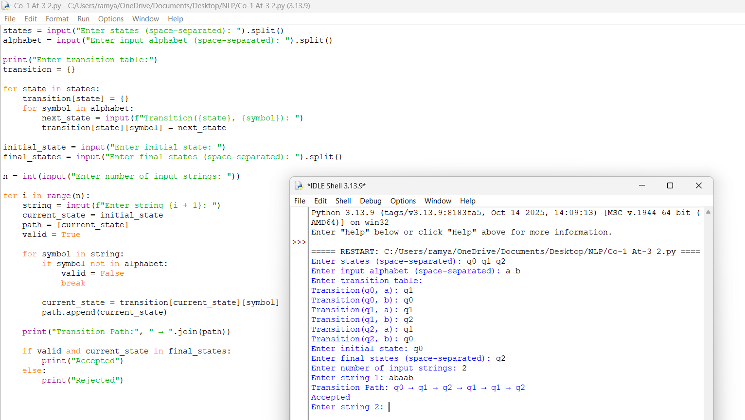
Section 3: Smart Pattern Matching Engine using Regular Expressions
3. Problem Statement
Develop a Python-based text search engine that performs pattern matching using Regular Expressions.
Code:
import re
text = """Meeting on 12/09/2026
Call 9876543210
@OpenAI
natural language processing"""
print("Text Search Engine")
print("1. Search Date")
print("2. Search Phone Number")
print("3. Search Hashtag")
print("4. Search Mention")
print("5. Search Prefix")
print("6. Search Suffix")
print("7. Search Word")
choice = input("Enter your choice: ")
if choice == '1':
pattern = r'\b\d{2}/\d{2}/\d{4}\b'
label = "Dates"
elif choice == '2':
pattern = r'\b[6-9]\d{9}\b'
label = "Phone Numbers"
elif choice == '3':
pattern = r'#[A-Za-z0-9_]+'
label = "Hashtags"
elif choice == '4':
pattern = r'@[A-Za-z0-9_]+'
label = "Mentions"
elif choice == '5':
prefix = input("Enter prefix: ")
pattern = r'\b' + re.escape(prefix) + r'\w*'
label = "Prefix Matches"
elif choice == '6':
suffix = input("Enter suffix: ")
pattern = r'\b\w*' + re.escape(suffix) + r'\b'
label = "Suffix Matches"
elif choice == '7':
word = input("Enter word to search: ")
pattern = r'\b' + re.escape(word) + r'\b'
label = "Word Matches"
else:
print("Invalid choice")
exit()
matches = re.findall(pattern, text, re.IGNORECASE)
print(label + ":")
if matches:
for match in matches:
print(match)
else:
print("No matches found")
Expected Output:
Text Search Engine
1. Search Date
2. Search Phone Number
3. Search Hashtag
4. Search Mention
5. Search Prefix
6. Search Suffix
7. Search Word
Enter your choice: 3
Hashtags:
#NLP
Output:
